Quick Summary

Stage 1 — Understand the Network
Used to understand shipment scale, lanes, and carriers.
- Overall shipment summary
- Lane performance
- Carrier performance

Stage 2 — Measure Service and Cost Control
Used to measure delivery reliability, billing control, overspend, and capacity use.
- OTIF / on-time rate
- Invoice exception rate
- Cost leakage
- Utilization

Stage 3 — Normalize and Compare Performance
Used to compare lanes and carriers fairly using normalized cost and service measures.
- Cost per shipment
- Cost per mile
- Cost-to-service view
- Transit variance

Stage 4 — Find Improvement Opportunity
Used to prioritize risk, find savings, and estimate future gains.
- High-risk lane ranking
- Consolidation opportunity indicators
- Monthly trend KPIs

Stage 1 — Understand the Network

1) Overall shipment summary
This is the first KPI because it gives a top-level picture of the dataset after loading it into PostgreSQL. The query usually calculates total shipment count, total freight spends, total weight moved, number of lanes, and number of carriers using functions like COUNT, SUM, and AVG. We write this query first to validate that the dataset is complete and to create a baseline for the whole project. It helps us understand the scale of the operation before moving into detailed lane or carrier analysis.
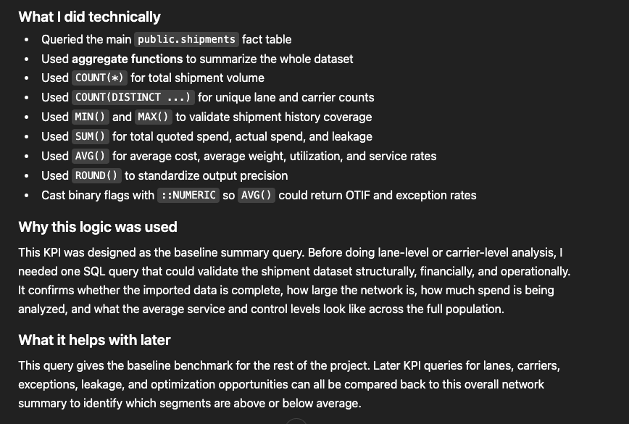

2) Lane performance
This KPI tells us how each origin-destination lane is performing. The query groups the shipment table by lane_id and calculates shipment count, total spend, average cost, transit performance, utilization, and exceptions. We write this because the lane is the main operating unit in the project, and later many business decisions depend on knowing which routes are efficient and which are weak. It helps us identify route-level patterns and prepares us for lane ranking and optimization later.
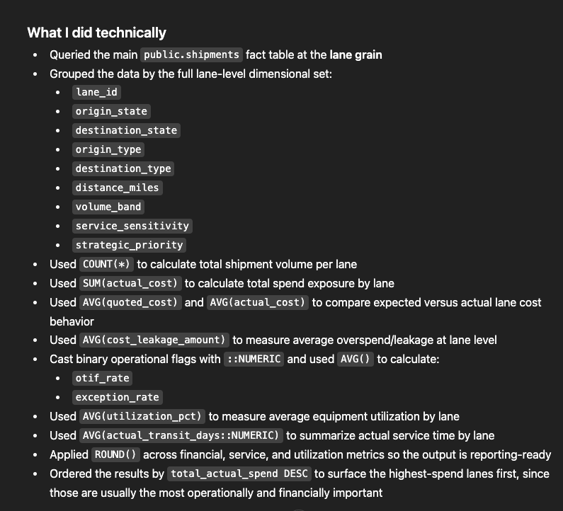
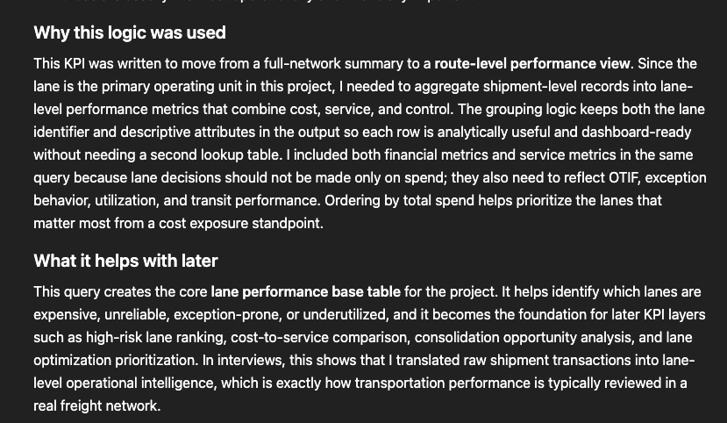

3) Carrier performance
This KPI measures how each carrier performs across all shipments. The query groups shipments by carrier_name and calculates shipment volume, total spend, average cost, on-time performance, invoice exception rate, and utilization. We write this query because carrier choice is one of the main controllable levers in transportation management. It helps us understand which carriers are reliable, which carriers are costly, and where carrier mix changes may improve results.
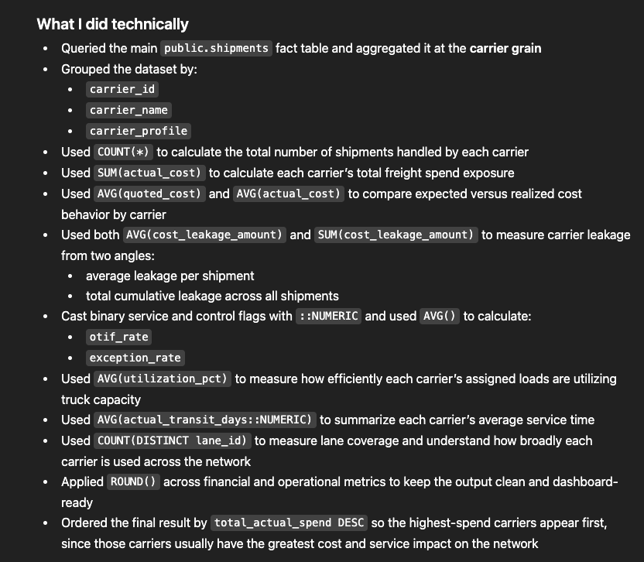
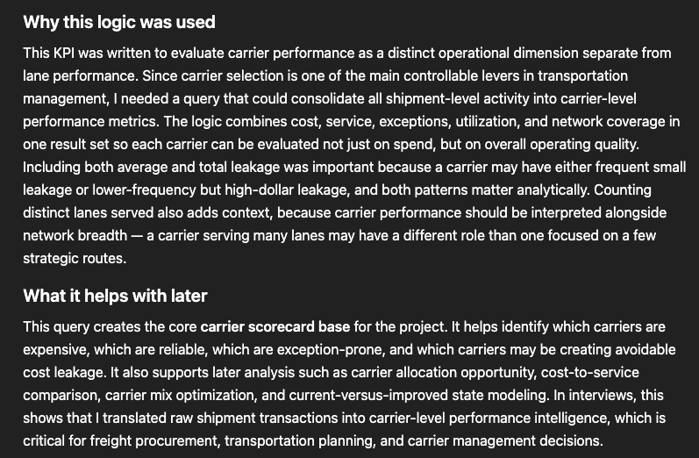

Stage 2 — Measure Service and Cost Control
This stage answers: are we delivering well and controlling transportation properly?

4) OTIF / on-time rate
OTIF measures the percentage of shipments delivered on time versus plan, usually using actual_transit_days <= planned_transit_days or on_time_flag = 1. We use this KPI to track service reliability and see whether lanes, carriers, or time periods are meeting expected delivery performance.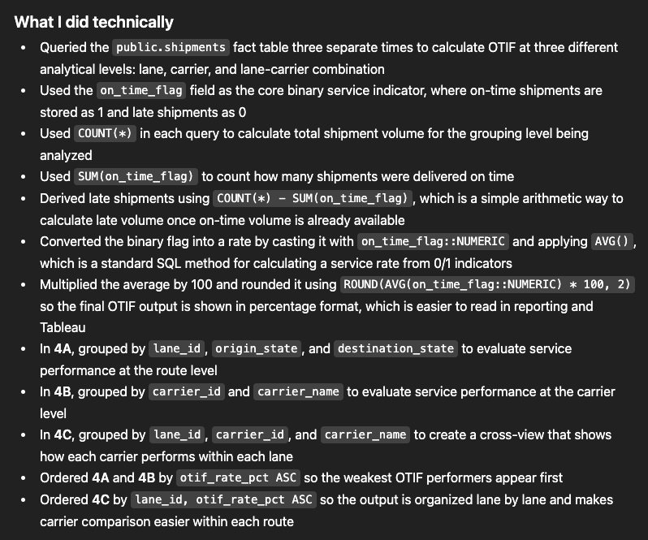
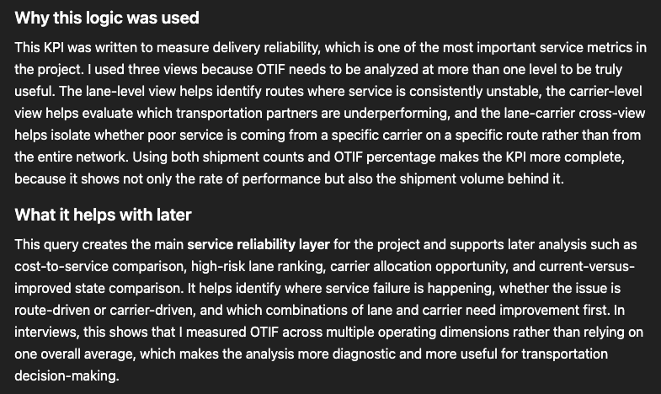

5) Invoice exception rate
This KPI measures how often shipments have an invoice or billing exception. The query calculates the percentage of shipments where invoice_exception_flag = 1, often grouped by lane, carrier, or time period. We write this because invoice exceptions often signal weak transportation controls, hidden billing issues, or process gaps. It helps us identify where transportation execution is becoming financially messy or difficult to control.
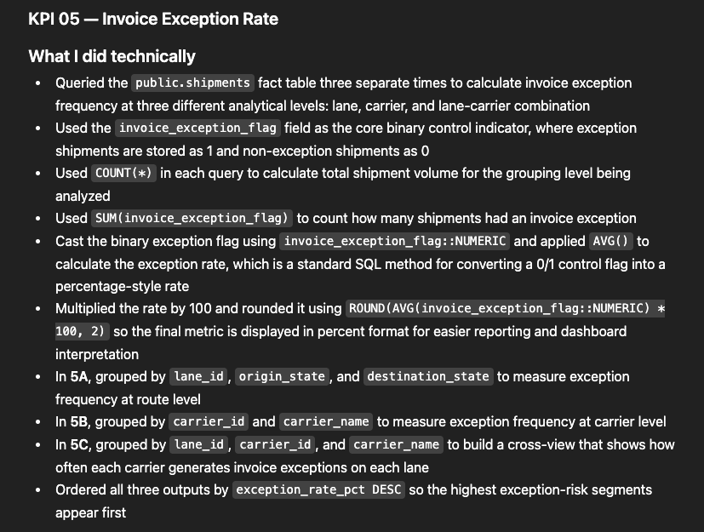
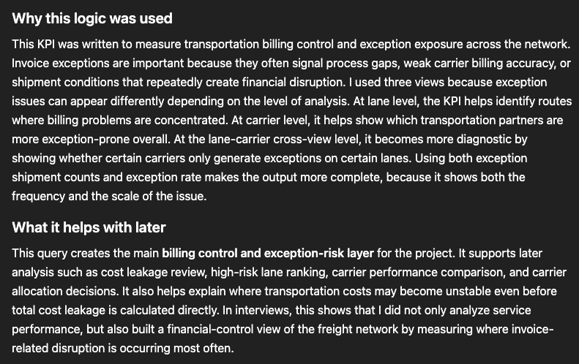

6) Cost leakage
Cost leakage measures the difference between actual billed cost and quoted or expected cost. The query calculates actual_cost - quoted_cost at the shipment level and then summarizes it by lane, carrier, or month. We write this because total spend alone does not show where overspend is coming from. This KPI helps us find exactly where money is being lost through billing overages, planning failures, or exception-prone movements.
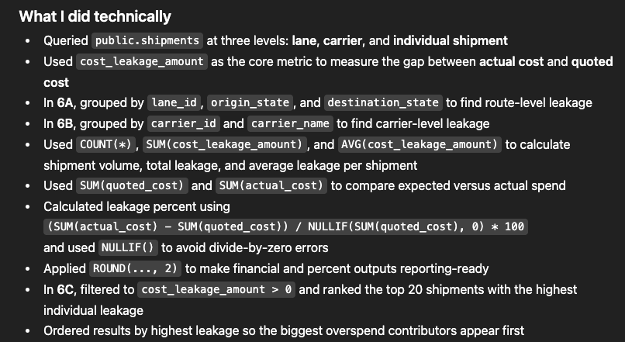
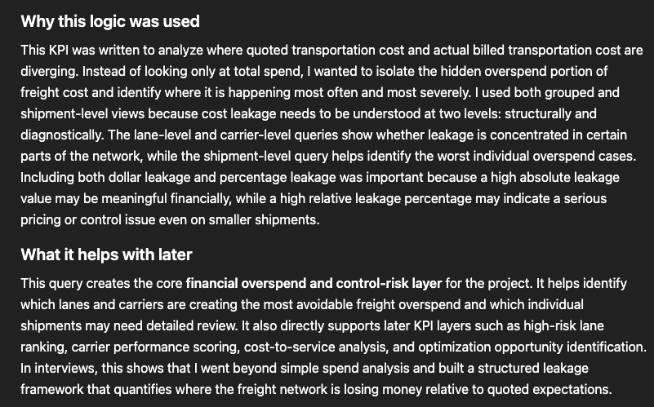

7) Utilization
Utilization shows how full the truck is relative to available capacity using a field like utilization_pct. The query calculates average utilization by lane, carrier, or month. We write this because poor utilization means transportation capacity is being wasted, even if shipments are delivered successfully. This KPI helps us detect inefficiency and supports future consolidation analysis.
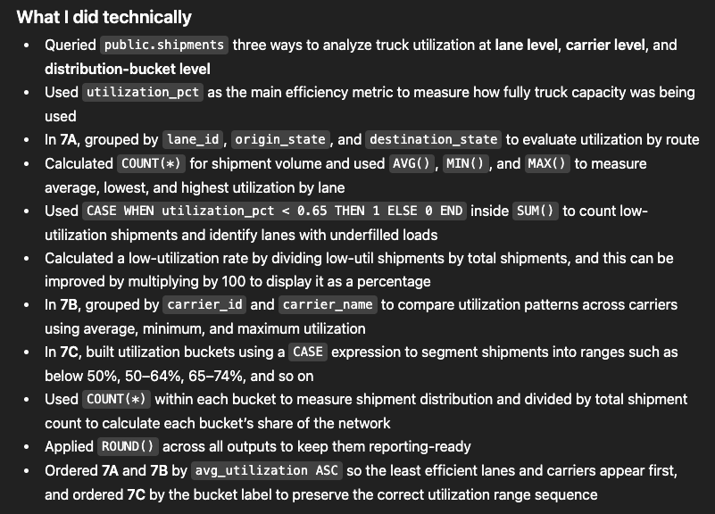
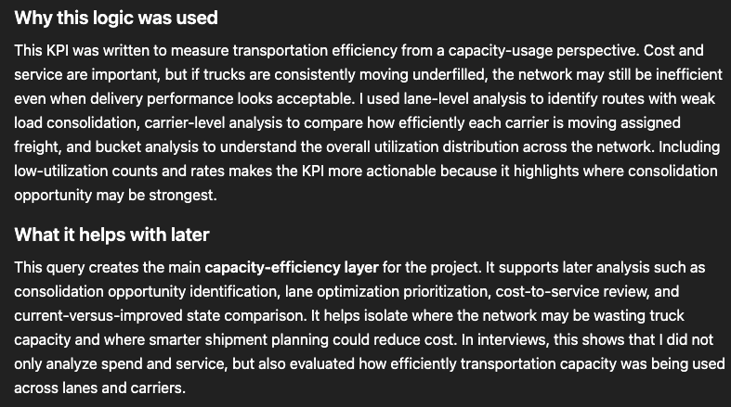

Stage 3 — Normalize and Compare Performance
This stage answers: which lanes or carriers are truly efficient or inefficient when measured fairly?

8) Cost per shipment
This KPI calculates average freight cost per shipment using SUM (actual_cost) / COUNT(shipment_id) or a grouped version by lane or carrier. We write this because high total spend may simply reflect high shipment volume. Cost per shipment gives a normalized view of transportation cost and helps compare routes and carriers more fairly.
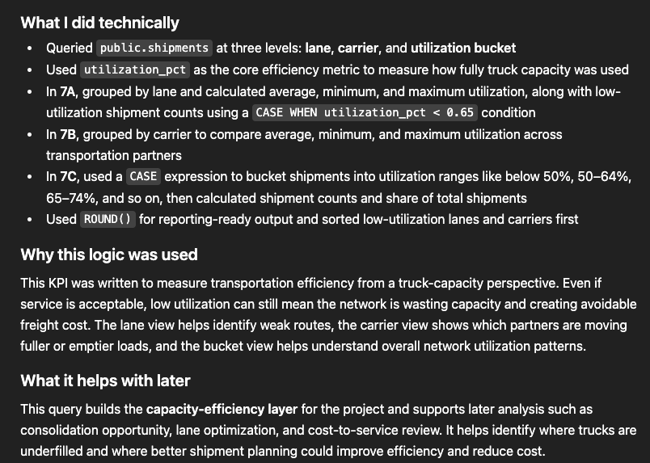

9) Cost per mile
This KPI measures the cost of moving freight per mile, usually calculated as actual_cost / assumed_distance_miles. We write this because shipment cost should always be judged relative to route length. It helps us compare short-haul and long-haul routes more accurately and supports lane efficiency analysis.
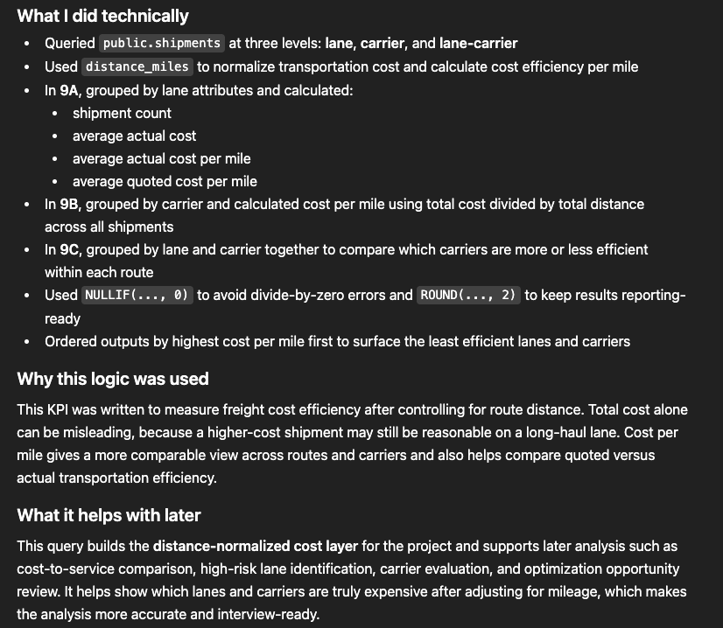

10) Cost-to-service view
This KPI combines the two most important transportation dimensions: cost and service. The query usually joins cost metrics such as cost per shipment or cost per mile with service metrics such as OTIF, transit variance, or exception rate. We write this because low cost alone is not a win if service is weak, and good service alone may not justify excessive cost. This KPI helps us identify lanes or carriers that are both expensive and unreliable, which makes them strong improvement targets.
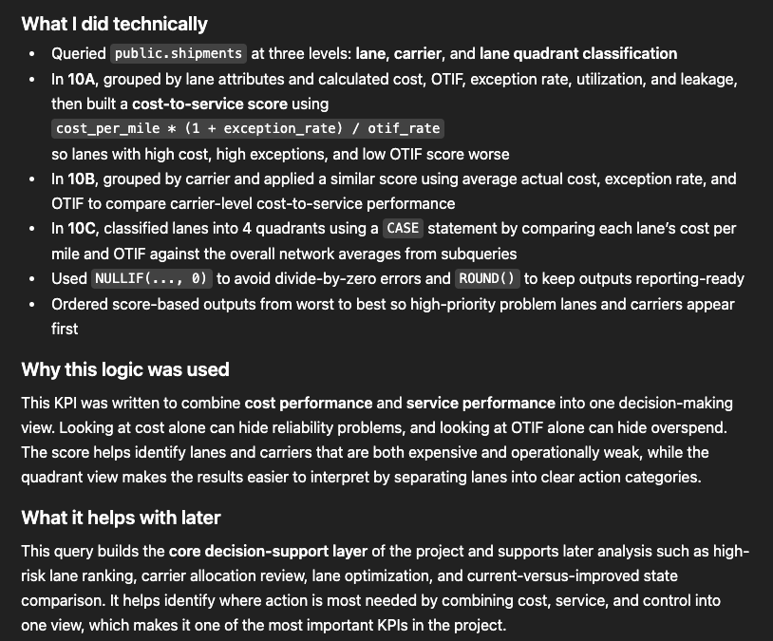

11) Transit variance
Transit variance measures how far actual delivery timing differs from plan using actual_transit_days - planned_transit_days. We write this because a basic on-time flag can hide how unstable delivery timing really is. This KPI helps quantify schedule drift and provides a more detailed view of reliability.
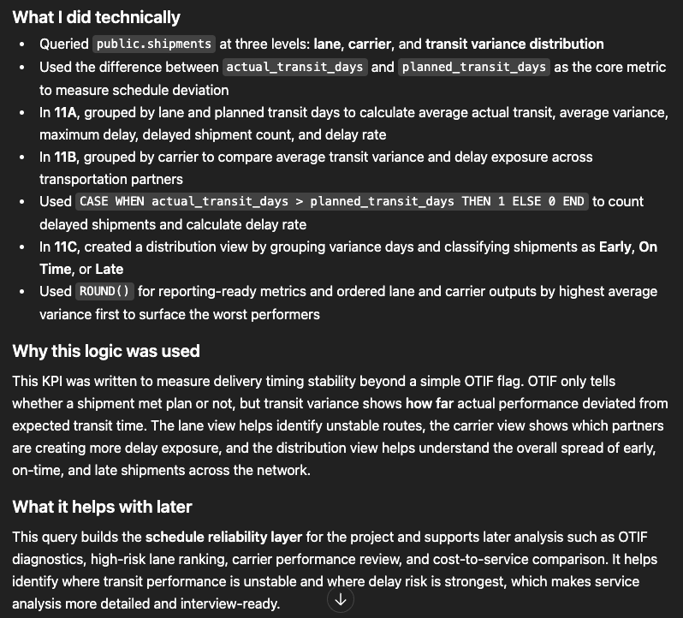

Stage 4 — Find Improvement Opportunity
This stage answers: where should we act, and what can we improve?

12) High-risk lane ranking
This KPI ranks lanes based on combined risk factors such as poor OTIF, high invoice exceptions, high cost leakage, and weak utilization. The query usually creates a lane-level scoring or ranking logic from multiple KPIs. We write this because management needs a prioritized list of problem lanes, not just many separate metrics. This KPI helps identify which routes should be reviewed first.
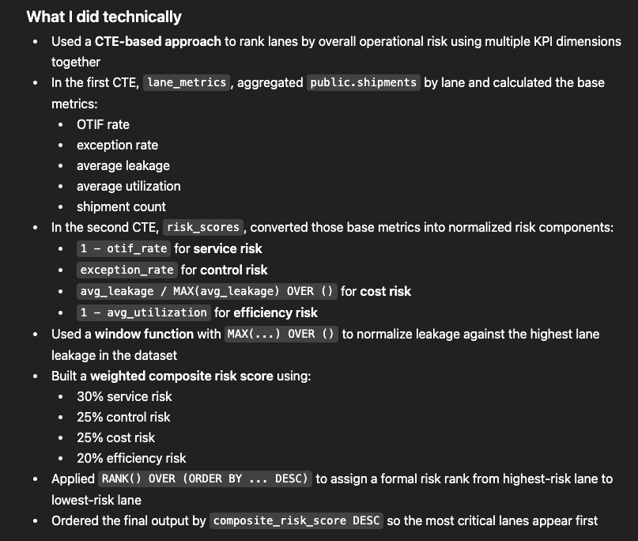
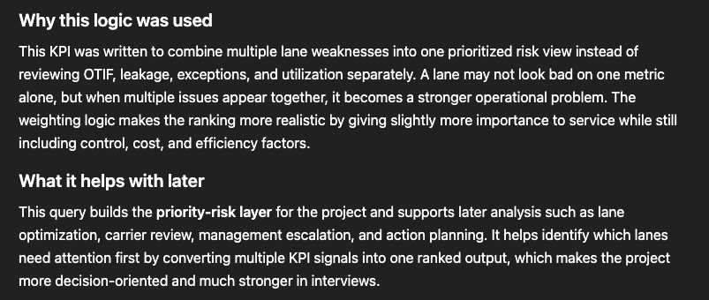

14) Consolidation opportunity indicators
This KPI identifies lanes where shipments may be too small, too frequent, or too underutilized. The query usually looks for low average utilization, repeated small loads, or patterns suggesting that shipments could be combined. We write this because many transportation savings come from better shipment planning, not just cheaper carriers. This KPI helps us identify where fuller, fewer loads may improve cost efficiency.
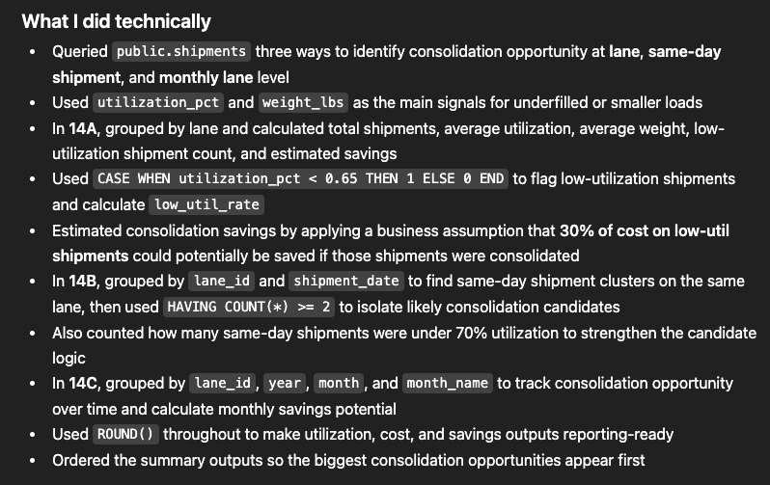
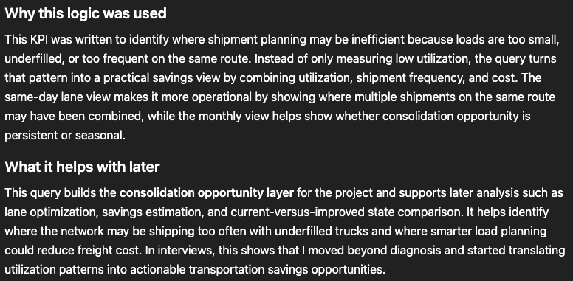

15) Monthly trend KPIs
These KPIs track changes over time, usually by month, for spend, OTIF, invoice exceptions, utilization, or leakage. The query groups shipments by month and measures trend movement. We write this because static averages can hide whether performance is improving or getting worse. These KPIs help us understand how the network behaves over time and make the dashboard more dynamic.
